Document Control: Private

Huracan Pty Ltd

3-Dec-23

Revision 1.5

2023

Explosive Safety and Security Plan

Huracan Pty Ltd

Huracan Pty Ltd

9-Mar-2015

Revision 1.1

Document Control: Public

**Explosive Safety and Security Plan Revision**

|  |  |  |  |  |
| --- | --- | --- | --- | --- |
| **Rev** | **Author** | **Reviewer** | **Date** | **Revision Comments** |
| **1.0** | **J. Hollingworth** | **B. Crowdey** | **15-Mar-23** | First Edition of Document for Review and Submission |
| **1.1** | **J. Hollingworth** |  | **21-Jun-23** | Edited to reflect Helidon as the Primary Explosive storage location. |
| **1.2** | **J. Hollingworth** |  | **3-Aug-23** | Add additional information on the storage of explosives. |
| **1.3** | **J. Hollingworth** | **R. Stewart** | **24-Aug-23** | Recommended adjustment after review from Resources Safety & Health Queensland |
| **1.4** | **J. Hollingworth** | **R. Stewart** | **3-Sep-23** | Additional recommended adjustment after review from Resources Safety & Health Queensland |
| **1.5** | **J. Hollingworth** | **RSHQ** | **3-Dec-23** | Amended for importation of explosives and reviewed by Resources Safety & Health Queensland |

Document Control: Public

Table of Contents

1 Document Control 6

1.1 Review and Update Procedures 6

1.2 Distribution 6

1.3 Document Updates 6

1.4 Document Publication and Display 6

1.5 Display Locations 6

2 Overview 7

2.1 Huracan General Code of Behaviour 7

2.2 Terminology 7

3 Statement of Standard 9

4 Objective 9

5 Scope 9

6 Responsibility 10

6.1 Consignor 10

6.2 Carrier 10

6.3 Employer / Authority Holder / Operations Manager 10

6.4 Health and Safety Responsible Personnel 10

6.5 Explosive Licensed Cased Hole Technician / Operators 11

7 Hazard Assessment 11

8 Management of Safety and Security 12

8.1 Safety Policy 13

8.2 Organisation Structure and Responsibilities 14

8.3 Systematic Procedures 15

8.3.1 Hazard Identification and Risk Management 15

8.3.2 Information, Training and Competency 16

8.3.3 Reporting and Investigation of Explosives Incidents 16

8.3.4 Monitoring and Review 16

8.3.5 Explosive Record Keeping 17

8.3.6 Additional Record Keeping 17

8.3.7 Legislation Compliance 18

8.3.8 Management of Change 18

8.3.9 Management of Security Risks 18

8.4 Operational Procedures 18

8.4.1 Access Management 19

8.4.2 Asset Management 19

8.4.3 Storage and Handling of Explosives 19

8.4.3.1 Huracan storage location 19

8.4.3.2 Huracan Storage Outside of government Magazine 20

8.4.4 Using Explosives under the Authority 20

8.4.5 Management of Unsafe Behaviours 21

8.4.6 Personal Protective Equipment (PPE) 21

8.4.7 Waste Management 21

8.4.8 Testing of Safety Shut-off System and Alarms 21

8.4.9 Transporting Explosives 21

8.4.10 Handling Chemicals 23

8.4.11 Movement of Explosives Management 24

8.4.12 Handling Miss-fires 24

8.4.13 Operating Plant and Equipment used in Activities 24

8.4.14 Emergency Preparedness and Response 24

8.4.15 Management of Change 25

8.4.16 Record and Handling complaints about the activities 25

8.4.17 Destruction of Explosives 25

8.4.17.1 Destruction Procedures 26

8.4.17.2 Mandatory considerations During Disposal 27

9 Importation of Explosives 27

9.1 Import Process 27

9.1.1 Packaging 28

9.1.1.1 Damaged Packaging 28

9.1.2 Globally Harmonised System of Classifying and Labelling of chemcials (GHS) 28

9.1.3 Package Approval 28

9.1.4 Packaging and Unit Loads 29

9.1.5 Package Marking 29

9.1.6 Air Freight Container 29

9.1.6.1 Prohibited Marking 29

9.1.6.2 Acceptance of Class 29

9.1.7 Sea Freight Containers 30

9.1.7.1 Lining the Shipping Container to AEC Requirements 30

9.1.7.2 Timber Used Within the Container 31

9.1.7.3 Securing of Load Within the Freight Container 31

9.1.7.4 Fumigation 32

9.1.8 Marking and Placarding 32

9.1.8.1 Placarding for Sea Freight 32

9.1.8.2 Placarding for Road Transport in Australia 32

9.2 Shipping 33

9.2.1 Dedicated Charter 33

9.2.2 Liner Service 33

9.2.3 Vessel Suitability 34

9.3 Importation Documentation Process 34

9.3.1 Import Licences 34

9.3.2 Australian Border Force/Customs Entry 35

9.3.3 Department of Agriculture, Water and the Environment 35

9.3.3.1 Brown Marmorated Stink Bug (BMSB) 36

9.3.4 Notificaton of Import to State Regulator 36

9.3.5 Port Authority Notification 37

9.4 Import Handling Operations 37

9.4.1 Air Freight 37

9.4.2 Sea Freight 37

9.4.2.1 Liner Port 37

9.4.2.2 Charter Port 37

9.4.2.3 Stevedores 38

9.4.2.4 Transport 38

9.4.3 Air Freight and Sea Freight - Authorised Representative 38

9.4.4 Resolution of Issues 39

9.4.4.1 Inadequate Packaging 39

9.4.4.2 Incorrectly Marked Boxes 39

9.4.4.3 Inadequate Securing of the Cargo 39

9.4.4.4 Shifted Cargo 40

9.4.4.5 Foreign Matter Inside or Outside the Container 40

9.4.4.6 Out of Date Explosives, Leaking Material, Out of Specification 40

9.4.5 Fumigation 40

9.4.6 Pre-Arrival Checklist 41

9.5 Preparation for Road Transport 41

9.6 Container Unloading 42

9.6.1 Deconsolidating the Container 42

9.7 Regulatory Requirements Specific to Explosives 43

9.7.1 Explosive Limits – Ports and Airports 44

9.7.2 Chain of Responsibility 44

10 Reference Library 45

Appendix A – Authorised Unsupervised Access Personnel 46

Appendix B – Corporate Explosive Licence 47

Appendix C – Approved Vehicles for Transport of Explosives 49

Appendix D – Explosive Emergency Procedure 50

Appendix E – Explosive Manifest 52

Appendix F – Transport Risk Categories for Explosives 53

Appendix G – Marking of Road Vehicles 54

Appendix H - Information bulletin no.71 List of authorised explosives 55

Appendix I – Authority Contacts 56

Appendix J - Import Explosives Vessel Chartering Checklist 57

Appendix K – Explosives Importation Guidelines 59

Appendix L – List of Potential Explosives to be Imported 61

# 1 Document Control

## 1.1 Review and Update Procedures

This document is a ‘live’ document that shall be reviewed and updated as per the Huracan Document Control and Revision Standard with a minimum period of 1 year.

It is also to be reviewed immediately after any of the following;

• Major operational incident (i.e. increased apparent risk)

• Significant operational, procedural, work practice or technology change

• New or amended safety codes, safety requirements or standards are issued.

• When required by relevant State and Federal Government legislation.

Huracan Management is responsible for the review and revision of this document. The updated document is to carry a new revision date and is circulated once the revision has been approved by the following level of Management:

• Operations Manager – Huracan.

## 1.2 Distribution

Distribution of this document is through HIMS in the “document reports” section and is available to all employees on completion of the Huracan induction once intranet access has been granted. Requested changes to the Distribution List are to be addressed to Huracan Management.

## 1.3 Document Updates

Huracan personal are to be advised of any revision changes to this document. Only registered copies of the document shall be updated. The latest revision is available on HIMS in the “document reports” section. This document becomes uncontrolled when printed.

## 1.4 Document Publication and Display

This document is accessible through HIMS and shall be displayed at all times in the Huracan office and shall be open for inspection by anyone to whom the plan or part of the plan may affect or apply.

## 1.5 Display Locations

This document shall be available for display at the following locations;

* Huracan Office
* Huracan Information Management System (HIMS) via controlled access through Huracan.com.au

# 2 Overview

## 2.1 Huracan General Code of Behaviour

Huracan Management requires full compliance with the Standard. Infringement of the standards contained in this document shall be regarded as a serious breach of the Huracan code of behaviour and shall result in disciplinary action, which may include counselling or dismissal. Failing to follow safety instructions, deliberately interfering with safety equipment and systems, deliberate damage to equipment, stealing, vandalism, fighting, practical jokes, and horseplay shall not be tolerated and are considered to be serious breaches of the Huracan Code of Behaviour.

## 2.2 Terminology

|  |  |
| --- | --- |
| **Term** | **Definition** |
| AEC | Australian Explosive Code – Current Edition |
| Australian Border Force (ABF) | Federal Government agency responsible for border security, including Customs import and export |
| Authorised Name | The name authorised by the appropriate Commonwealth, State or Territory explosives regulator |
| Bonded Warehouse | A secure location is authorised by the Australian Border Force for the temporary storage of goods that have not yet been import-cleared with ABF. |
| Booster | An explosive charge that acts as a bridge between the high-sensitivity, low-energy detonator and the low-sensitivity, high-energy explosive |
| Cargo terminal | A place (other than a depot to which a depot licence relates or a warehouse to which a warehouse licence relates), within the limits of a port, airport or wharf, where:   1. Goods are located immediately after being unloaded from a ship that has taken the goods on board at a place outside Australia and carried the goods to a port or wharf in a State or Territory where some or all of the goods are unloaded or 2. Goods are located immediately after being unloaded from an aircraft that has taken the goods on board at a place outside Australia and carried the goods to an airport in a State or Territory where some or all of the goods are unloaded. |
| Cargo terminal operator | In relation to a cargo terminal means a person who manages the cargo terminal. |
| Carrier | An individual or organisation transporting explosives |
| Carrier’s Agent | Local agent who represents the interests of the carrier, either an airline or ship owner – in the local importation process |
| Consignment | A package, or load of explosives, which is presented by a consignor for transport |
| Consignor | Refers to the legal party shipping the goods from overseas |
| Consignee | Refers to the legal party receiving the goods from the international shipment |
| CTU | Cargo Transport Unit |
| Customs Broker | A third party who is licensed by the Federal Government to lodge import and export documentation with Australian Border Force and Department of Agriculture on behalf of an importer |
| Detonator | A device or small sensitive charge used to detonate an explosive |
| Explosive | A substance or a thing containing a substance manufactured or used  with a view to produce a practical effect by explosion or a pyrotechnic effect; Class 1 Dangerous Goods under the United Nations Recommendations and covering Hazard Divisions 1.1, 1.2, 1.3, 1.4, 1.5 and 1.6 |
| Explosives Incident | Means any of the following events involving an explosive:  a. An explosive is or appears to have been lost or stolen.  b. An accidental explosion, fire or spillage.  c. The death of or an injury to a person during the use of explosives.  d. Unexpected damage to property from explosives.  e. An event, including a misfire, with the potential to cause any of the events mentioned in paragraphs (a) to (d), other than an event that normally happens when handling or using an explosive. |
| Freight Forwarder | Third party agent who works on behalf of the shipper or Importer to make bookings with freight carriers. Often the same party as the Customs Broker |
| Holder | Of an authority means a person to whom it is issued or transferred. |
| License | An authority prescribed under a regulation to be a license |
| Magazine | Approved location with security and safety measures in place for storage of explosives. |
| Net Explosive Quantity (NEQ) | The actual quantity, expressed by mass, of explosive substance in an article, package or container |
| Package | A barrel, box, canister, case, tin or another container, and includes by which goods may be cased, covered, enclosed, contained or packed. |
| Possess | An explosive includes:  a. Have custody or control of the explosive; and  b. Have an ability or right to obtain custody or control of the explosive |
| Regulatory Authority | In each State or Territory, the regulatory authority is the body that issues and regulates the explosives license or permit. |
| Security Plan | A plan that has been put in place to effectively minimise security risks to the storage, manufacture, handling, and transport of explosives |
| Security Risk | The possibility of theft, unexplained loss, sabotage, and unauthorised access to explosives |
| Shipper | see **Consignor** |
| Ship’s Agent | Carrier’s agent when the importation is performed by ship. See **Carrier’s agent** |
| Ship Broker | 3rd party private company acts as an intermediary between a ship owner and the shipper or consignee in negotiating the chartering of a tramp vessel or space on a tramp vessel. |
| Shipping Line | Liner shipping company which operates vessels on a fixed schedule between fixed ports. These vessels call to container ports with dedicated container handling equipment. |
| Stevedore | The party who performs the physical act of unloading the cargo from the vessel |
| Tailgate Inspection | A visual inspection of the container internally and externally will be ordered by Department of Agriculture for any Container that is being unloaded outside the urban area. Random tailgate inspections may also be ordered as required. |

# 3 Statement of Standard

This document is intended to serve as the minimum Huracan requirements for the Management and mitigation of the risks associated with the storage, transport, possession and use of explosives. This plan has been formulated to interface with the company's existing Health, Safety and Environmental Management System (HSMS) to provide guidance and compliance with the Explosives Act 1999 and Explosives Regulation 2017.

This plan applies to all Huracan personnel and contractors who are involved with operations where explosives may be required. Compliance with this plan is mandatory by personnel to help ensure the safe handling, storage and transport of explosives operations.

# 4 Objective

To eliminate explosive-related incidents in our business that cause fatalities and injuries to employees, families, contractors and third parties and minimise damage to equipment through Management of all phases of explosive operations by;

* Identifying and managing explosive hazards and unnecessary exposure
* Preventing and mitigating the residual risk through the selection and preparation of people, training and industry best practices in association with explosive use.

# 5 Scope

This Standard applies at all times to all Huracan locations, Huracan employees and relevant contractors.

# 6 Responsibility

## 6.1 Consignor

To ensure that packages containing explosives are safe to handle under normal conditions, the consignor is responsible for the following:

* Packaging and labelling explosive materials for transport in accordance with the Transport Code; and
* Preparing and certifying the transport documentation as required by the Transport Code

## 6.2 Carrier

Checking that appropriate documentation is provided with the package and has been completed in accordance with the Transport Code

Verifying that the information on the consignment note, consignors declaration for dangerous goods (if applicable) and the package containing the explosive materials is consistent;

Identifying labels to ensure appropriate decisions are made about storage, loading and transport;

The loading, unloading, handling, transport and interim storage of packages where appropriate, including any directions given by the consignor, such as special stowage provisions for the safe dissipation of heat; and

Emergency procedures in the event of an incident while loading, transporting, unloading or storing a package.

## 6.3 Employer / Authority Holder / Operations Manager

Hold the appropriate license/s as prescribed by the relevant Authority:

* Huracan holds a Corporate Licence to possess explosives;
* Huracan personnel responsible for explosives hold the relevant State licence to use and complies with the restrictions of the licence.

Ensure, so far as is reasonably practicable, workers are appropriate persons to have access to or use explosives;

Take all reasonable precautions in regards to the storage of explosives to prevent an explosives incident and to minimise the likely effects of an explosives incident and ensure the storage place is approved in accordance with the prescribed obligations;

Notify the Chief Inspector of any incident where the explosives authorised is held involved in an explosives incident that results in any loss of life, personal injury or property damage.

## 6.4 Health and Safety Responsible Personnel

Identify ways, consistent with this plan for administering systems in the Management of the safety and security of explosives;

Identify if this plan is being complied with;

Review the plan in accordance with company processes to ensure its continued effectiveness;

Report, in accordance with the systems and prescribed obligations, any incidents in which explosives are involved.

## 6.5 Explosive Licensed Cased Hole Technician / Operators

Take all reasonable precautions and use reasonable care to avoid endangering any person’s safety, health or property;

Hold and maintain the relevant license for the operations required;

Ensure that the explosives are transported in accordance with prescribed obligations and this Explosives Safety and Security Plan, including delivery of the explosives to a place where they may lawfully be stored or used by someone who may lawfully possess it.

Ensure they are authorised by the Company to use and transport explosives;

Understand this explosives safety and security plan, their obligations and commit to complying with this plan and any safe systems of work required;

Actively participate in the required training and maintain the necessary competence to conduct operations;

Account for and maintain the handling, transport and use of any explosives in accordance with this plan;

Report any incidents or contraventions with this plan and subsequent regulatory standards to the HSE Representative or Authority Holder.

# 7 Hazard Assessment

Huracan may utilise explosives for down-hole perforation of oil and gas (including Coal Seam Gas) wells as operations require. The company recognises there is risk associated with this activity as detailed within the Hazard Risk Register. Details of the explosives utilised include:

|  |  |
| --- | --- |
| Type of Explosives handled | 1.1B and 1.1D |
| Amount of Explosives stored | <250kg of Explosives and <125 detonators |
| No. of Workers who may come in contact with Explosives | 12 |
| Total size (m) of Explosives Storage Site | 24 x 10 = 240m2 |
| No. of vehicles licensed to transport Explosives | Refer to the Appendix |
| Address of site of Explosives | 151 Warooby Lane, Euthulla, Qld, 4455. |
| Distance to hazardous or public space from store: | Nearest single dwelling – 180m |

Supporting Documents

Huracan_Risk_Register-Roma_RevX.X _DDMMMYY

# 8 Management of Safety and Security

A safety management system must be implemented, as per prescribed obligations, for the ongoing safe and secure administration of explosives. Huracan maintains an integrated Health, Safety Management System (HSMS) for the control of risks associated with current operations and the discharge of legislative and regulatory obligations. Further details of the functions of the HSMS which are applied to the execution of this Explosives Safety and Security Plan include, but are not limited to:

Safety Policy;

Organisational structure and responsibilities pertaining to the key roles and critical functions for the possession of, safe handling, storage, use and transportation of explosives;

Systematic Procedures:

* Hazard identification and risk management;
* Provision of information, training and Competency;
* Reporting and investigation of explosives incidents;
* Internal auditing of the systems;
* Monitoring and review of the systems for effectiveness;
* Record keeping;
* Legislative compliance review and currency;
* Systems changes; and
* Management of security risks.

Operational Procedures:

* Access management where explosives are used;
* Asset Management (maintaining & cleaning of suitable buildings, plant and equipment, restriction of ignition sources);
* Storage and handling explosives Management (under the authority, including security provisions and procedures, limiting the amount of explosives in, and the number of persons in, buildings and other places where the activities are carried out) and;
* Using explosives under the authority, including security provisions and procedures;
* Management of unsafe behaviours and other activities which may affect the risk associated with the handling, use and storage of explosives;
* Application of PPE;
* Waste management;
* Testing of safety shut-off systems and alarms;
* Transporting explosives under the authority, including security provisions and procedures;
* Handling chemicals and separating materials that are not compatible;
* Movement of Explosives Management (including receiving explosives at a place where activities are carried out);
* Handling misfires;
* Operating plant and equipment used in the activities, i.e. Wireline Unit, Pump, Cranes;
* Preparing for and responding to emergencies, including an evacuation plan, and the testing of the procedures and responding to adverse weather conditions (i.e. lightning);
* Changing operational processes, the composition of the explosives used for the activities, the ingredients used to manufacture explosives and, the packaging of explosives; and
* Recording and handling complaints about the activities.

## 8.1 Safety Policy

All Huracan Policies are maintained using the Huracan Information Management System (HIMS), including the Health and Safety Policy. Policies are displayed in the Roma Office and are available via the Company Server. Policies are reviewed in accordance with the Document Control and Review Standard (HSE_DocumentCRS). Huracan must always consult with Employees and applicable contractors in relation to safety matters when implementing new safety rules and policies and when alterations to existing policies would be considered a significant deviation.

## 8.2 Organisation Structure and Responsibilities

**Huracan Organisation Chart**

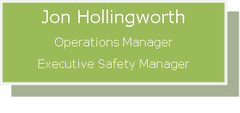



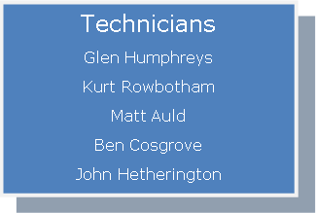

The Operations Manager shall be the Explosives Security Manager

Authorised persons (other than the Operations Managers) will primarily include:

* E-Line Field Technicians
* Wireline Operators

Responsibilities will be in accordance with prescribed regulatory obligations as communicated through training (licensing etc.), Personnel Training and Competency Requirement-FBFV and resource documentation i.e. JSA’s, SOP’s etc.

Staff must notify the Operations Manager if:

* The person has been convicted in Queensland or elsewhere of a relevant offence;
* A domestic violence order has been made in Queensland or elsewhere against the person at any time;

There is any other reason that would prohibit their ability to successfully secure their license (enabling access to the Explosives Compound), which includes:

1. Successfully pass a medical
2. The person’s ability to satisfy the statutory requirements (minimum age requirements, licences)
3. Successfully pass an ASIO check (includes both police criminal history check {PHC} and politically motivated check {PVM}
4. Produce 100 points of identification
5. Successfully pass any drug and alcohol tests (random, for-cause or scheduled)
6. Successfully pass a police clearance.

Expiry on any required licenses shall be managed by the individual and recorded within HIMS.

## 8.3 Systematic Procedures

### 8.3.1 Hazard Identification and Risk Management

Huracan manages risk in accordance with AS:31000 and the Code of Practice (Managing WHS Risk) of:

* Identify hazards
* Assess the risk
* Implement Controls
* Monitor Controls
* Review Controls for effectiveness

The Company has identified explosives as a significant risk associated with operations, as detailed within the Company Hazard Risk Register. Risk mitigation of explosives is communicated to relevant personnel and is the responsibility of the Operations Manager. Relevant tools to manage the associated risks include, but are not limited to:

* Relevant licenses
* Standard Operating Procedures (SOP’s)
* Job Safety Analysis (JSA’s)
* HS Management Plan (HSMP)
* Training and competency
* Resource documents (checklists etc.)

**Of note are the following JSA’s and SOP’s specific to Explosive Operations.**

* **Standard Operating Procedures;**
  + SOP WEX01 Gun Loading RevX.X
  + SOP WEX02 Wireline Explosives Field Operations RevX.X
  + SOP WEX03 Wireline Perforating RevX.X
  + SOP WEX04 Bridge Plug_Packer Setting Operations RevX.X
  + SOP WEX05 Titan Control RF Safe Perforating RevX.X
  + SOP WEX06 Titan Control RF Safe Bridge Plug_Packer Set RevX.X
  + SOP WEX07 Tubing Cutter RevX.X
  + SOP WEX08 String Shot RevX.X
* **Job Safety Analysis Procedures;**
  + JSA WEX01 Explosives Handling, Gun Loading & Transportation RevX.X
  + JSA WEX02 Arming, Running & Pulling Explosive Devices RevX.X
  + JSA WEX03 Bridge Plug_Packer Operations RevX.X
  + JSA WEX04 Pipe Recovery RevX.X
  + JSA WEX05 Tubing Punch_String Shot Bar RevX.X

**Supporting Documentation:**

Huracan_Risk_Register-Roma_RevX.X _DDMMMYY

### 8.3.2 Information, Training and Competency

Huracan recognises its obligations to provide training and instruction to personnel to assist in the performance of jobs and tasks in a healthy and safe manner. This extends to competencies for the handling, use and transport of explosives. All training and competency is managed in accordance with the Training and Development Procedure. Competency required includes, but is not limited to:

* Current Queensland Shot-firers License for use, or relevant States license if not Qld;
* Completed a relevant oil and gas field explosives safety school to API International and Local regulatory requirements;
* National Police Clearance;

All records of personnel training and licencing as related to explosives are to be recorded in HIMS in the Certifications sections. All licences and training certifications are to be uploaded to HIMS as an attachment to the individual's training records.

**Supporting Documentation:**

Personnel Training and Competency Requirement-FBFV RevX.X DDMMMYY

### 8.3.3 Reporting and Investigation of Explosives Incidents

All Incidents must be reported to the Operations Manager and investigated in accordance with the Incident Management Procedure. Any incident involving explosives must be reported to the Operations Manager immediately, who is responsible for reporting to the Regulator in accordance with the required timeframe.

In the event any evidence of attempted forced entry, theft of explosives or unaccountable stock discrepancy occurs, the responsible person must report the event immediately to the Police.

An incident investigation must be recorded in HIMS under the HSSE Report section. All action items recorded must have a reasonable time frame associated with closure and must have a final review with the Operations Manager prior to closure.

**Supporting Documentation:**

Audit & Inspection Schedule YYYY

### 8.3.4 Monitoring and Review

The monitoring and measurement of records provide critical information as to the effectiveness of the Management of HSE matters, including lead (positive) and lag (negative) indicators. Statistics gathered are analysed to ascertain trends and allow for strategic planning in the prevention of reoccurrence or preventing incidents. Data captured regarding explosives, such as stock counts, incident reviews, and quality control feedback, will assist in the Company’s ongoing commitment to continual improvement.

This Management Plan shall be reviewed as prescribed by the relevant legislation not less than annually. All audits (both internal and external) and statistics must be recorded and uploaded to HIMS under the Documentation Report section.

### 8.3.5 Explosive Record Keeping

Good record-keeping is critically important in the safety and security of Explosives. Records should be kept of all explosive Import transactions and should record;

* the name of the explosive;
* the amount of the explosive;
* the date the explosive was brought into the State or sent to the country;
* the name of the consignee and consignor of the explosive.

A Dual record inventory system will be kept manually inside the magazines and at the base. The balances should be reconciled monthly. See below for a sample storage sheet that is to be updated when explosive inventory is moved in and out of the bunkers:



**Supporting Documentation:**

Document Control and Review Standard (HSE_DocumentCRS_RevX.X _DDMMMYY)

### 8.3.6 Additional Record Keeping

Paper records must be kept and recorded in HIMS (when practicable) that relate to the following items;

1. internal audits and statistics;
2. risk assessments undertaken;
3. training of personnel;
4. reports and investigations of explosives incidents;
5. reviews of operational procedures;
6. consultations with employees and contractors about safety;
7. explosives manufactured or stored under the authority;
8. maintenance carried out on buildings, plant and equipment;
9. testing of safety shut-off systems and alarms;
10. testing of emergency procedures and the evacuation plan;
11. disposal of explosives;
12. alternative safety and security measures used

### 8.3.7 Legislation Compliance

All legislative compliance is managed via 3rd Party Subject Matter Experts (SME) document review. Legislation consulted in the preparation of this Explosives Safety and Security Plan includes:

* Explosives Act 1999 (Qld)
* Explosives Regulation 2017 (Qld)
* AS2187.1 – 1998 Explosives – Storage, Transport and use Part 1: Storage
* AS2187.2 – 2006 Explosives – Storage and use Part 2: Use of explosives
* Australian Code for the Transport of Explosives by Road and Rail 3rd Edition
* Australian Code for the Transport of Dangerous Goods by Road and Rail Edition 7.4

This Manual has been created using an SME.

### 8.3.8 Management of Change

Any changes required to the Huracan HSMS shall be managed via the Management of Change Section of the Heath and Safety Management Plan. For example, Management of change shall be required for procedural changes, or management review may facilitate systematic changes. Changes shall be communicated to all relevant parties via direct communication to relevant parties through email and email confirmation.

### 8.3.9 Management of Security Risks

Security risks are managed in accordance with risk management principles. Risks identified and corresponding controls are detailed within the Hazard Risk Register. Further guidance is provided within the Operational Procedures (following). Huracan has determined the security risk/s posed with regard to the storage, transport and use of explosives is low.

**Supporting Documentation:**

Huracan_Risk_Register-Roma_RevX.X _DDMMMYY

## 8.4 Operational Procedures

### 8.4.1 Access Management

Key Security

* Magazines, magazine compound yard and gate access to the compound yard are kept locked at all times;
* Keys to the Explosives magazines are only accessible by request to the Operations Manager. Only authorised persons shall be issued the key for access to the explosives storage facility.
* Keys must be returned immediately after removing the required explosives;
* The keys to the magazines are clearly labelled with chains welded to the keys and the T-Bar lock mechanism.

Authorisation

An authorised person must have at least the following:

1. Current Queensland Shot-firer License for use;
2. Completed a relevant oil and gas field explosives safety school and Local regulatory requirements

### 8.4.2 Asset Management

The compound yard will be kept clear of any weeds, rubbish or other debris that may pose a fire hazard.

A standard poisoning routine shall be kept by inspection and completed as required.

No work is to be permitted to be carried out inside any magazine. The Magazine compound yard is purely for the purpose of storage only.

No smoking is allowed inside the compound yard. All lighters, matches, cigarettes and non-intrinsically safe items are allowed within the compound (they must remain a safe distance away / outside the compound)

### 8.4.3 Storage and Handling of Explosives

#### 8.4.3.1 Huracan storage location

Huracan’s bulk explosive storage facility will be the Government Explosive Reserve in Helidon, east of Toowoomba. Huracan will require primary and secondary storage. Huracan will apply for access to the facility once a Corporate licence has been obtained. Only Huracan personnel with an “authority to use” licence issued by the QLD Explosive Chief Inspector will be granted access to the facility, and the individual is subject to all safety and security conditions of the Explosive Reserve.

Helidon contact details;

Email: HelidonGER@rshq.qld.gov.au

Phone: (07) 4612 9400

The following must be adhered to when accessing the Helidon.

**Prior to shipping of explosives to Helidon;**

* A copy of all applicable explosives licences.
  + Ensure that the Helidon storage facility has received copies of all applicable documents prior to shipping Huracan explosives.
* Completion of the Helidon ‘Request to Store’ prior to all shipment and inward transactions.
  + Complete the form and have the document reviewed prior to submitting.
  + Confirm receipt of the document from Helidon and that it adheres to the required standards.
* All explosive products must be authorised and in specification (not damaged).
* All cases must be compliant, UN Approved, sealed and quantities noted.

Prior to accessing the Helidon Sotage Facility;

* Ensure that a list of vehicles and personnel (and copies of relevant licences) are current with Helidon requirements for accessing the facility and Huracan stock.
* Completion of a Reserve induction has been completed.
* Helidon has received a minimum of 24-hour notice prior to the transfer of inventory.
* AEC3 (Australian Explosive Code) -compliant paperwork must be provided for all transactions.

Monthly Requirements for Storage at Helidon;

* A monthly stocktake is to be provided to the Facility Administrator each month for reconciliation of Huracan and Helidon inventory compliance.

#### 8.4.3.2 Huracan Storage Outside of government Magazine

Huracan personnel with an “authority to use” licence issued by the QLD Explosive Chief Inspector will be responsible for the explosives once they have been removed from the Government Reserve Storage Facility in Helidon. The Huracan personnel “authority to use” licence holder is responsible for the safe transport and storage of the explosives in their care until returned to the Government Reserve. The explosives may be stored at the wellsite in appropriate explosive containers.

Short-term storage of explosives when in the Huracan Facility for the purpose of upcoming job activity must be stored in an appropriate explosive-compliant carry or day box outside of a vehicle.

Explosives may be transferred to another Huracan person with the appropriate “authority to use” licence only once the following has been completed.

* An explosives physical count must be performed by both personnel, and any discrepancies must be reconciled.
* Both individuals will sign off the explosive count sheet and transported with the explosives.

### 8.4.4 Using Explosives under the Authority

All perforation work will be performed by the Huracan Crew under the direct supervision of a trained and authorised E-Line Field Technician;

All perforation work shall be undertaken per the Client's programme

All perforation work will be performed as per procedures to Australian Standard and API perforating best practice. Applicable perforating hardware manuals should be consulted for all perforating device loading and use.

### 8.4.5 Management of Unsafe Behaviours

Company Contraband Policy is enforced to ensure the worksites are drug and alcohol-free;

All smoking and non-intrinsically safe items must not be allowed near any explosive service activity;

Exclusion zones and additional controls shall be communicated to all relevant personnel at the site during the Pre Job Meeting and documented on the Huracan Pre-Job Safety & Induction Record and, as required, the Wellsite Permit to Work.

An exclusion zone shall be set by Huracan personnel, with all non-essential personnel to remain outside this set where explosives are being used or loaded.

### 8.4.6 Personal Protective Equipment (PPE)

Safety Data Sheets (SDS) should be reviewed prior to the handling of any chemical substance to ensure no additional control measures are required. A review of the applicable SDS has determined there is no additional PPE required when handling or transporting explosives.

**Supporting Documentation:**

Safety Data Sheets (SDS) as applicable

Associated Chemical Substance Risk Assessments

### 8.4.7 Waste Management

All remnants of explosives shall be returned to the Roma Storage Facility after operations, where it will remain (separated) to be destroyed by a 3rd party taking part in bulk destruction of the Dangerous Goods.

### 8.4.8 Testing of Safety Shut-off System and Alarms

Due to the limited quantity of explosives stored and transported, Huracan does not have safety shut-off systems or alarms within the storage compound. Perforating operating plant safety shut-off systems that are regularly checked as part of a daily checklist.

### 8.4.9 Transporting Explosives

Transporting explosives is normally for oil and gas operators from the Helidon Government store to the Huracan Facility and then to the Client's field site, i.e. Huracan’s Roma base to Santos’s Roma North Field. Transportation occurs as operations require; therefore, typically, explosives are not transported on a regular schedule but more randomly. The distance explosives are transported will vary depending on the Client and location. However, it is expected a journey would not exceed 1,000km.

Only Huracan personnel with an “authority to use” licence issued by the QLD Explosives Chief Inspector will be permitted to transport explosives. The licence allows <250kg of explosives to be transported.

All vehicles containing explosives shall:

* Be either attended the Huracan “authority to use” licence holder or guarded if left stationary;
* Are secured at temporary stops or when the driver is not in the vehicle, preferably within the view of the Huracan “authority to use” licence holder or guarded and inaccessible to the public with the keys removed and on the driver at all times;
* Are parked at least 5m away from combustible materials, including tall, dry vegetation, fuel and LP Gas storage;
* Vehicles are not parked in the same place for consecutive days or nights unless the local police and emergency services have been notified;
* If there is no contact from the driver within a reasonable timeframe of checking in (3 hours), the Explosives Security Manager (Operations Manager) will begin action to ascertain the situation i.e. use IVMS to locate the vehicle and activate the emergency response plan as required.

All Huracan vehicles are fitted with In-Vehicle Monitoring Systems (IVMS), which provide live, real-time location-enabling tracking. All vehicles will have a first aid kit available and inspected as part of Huracan’s audit and inspection calendar.

Huracan vehicles transporting explosives will have an accredited day box secured to the tray with a Huracan master key lock. These day boxes are manufactured to comply with the Australian Explosives Code 3rd Edition 2009 and to Quality Assurance accreditation ISO:9001 and shall:

1. Be lockable;
2. Inner surface is made of wood or some other material incapable of producing incendive sparks;
3. Constructed strong enough to maintain its integrity during transport and adequately provide protection and security for the goods contained within;
4. Is weatherproof;
5. Closed and has a continuous floor;
6. Is securely attached to the vehicle.
7. Is authorised vehicle must also carry the following documentation:
8. Current Vehicle License to Transport Explosives;
9. Emergency Procedures & Guides;
10. Appropriate SDS for goods carried; and
11. A Packing List

The Types of Explosives transported by Huracan fall into Category 1 (Low-Risk Category), see Appendix F for further details. This means that the vehicles are exempt from the marking of road vehicles for transporting explosives (See Appendix G for further detail) as the explosives are categorised as “generically authorised explosives used in the petroleum, gas and geothermal industries” (See Appendix H for further detail).

As per AEC Code 3, Section 8.2.3 Requirements for Drivers of Road Vehicles as applies to Explosives for Oil and Gas and Geothermal Industries.

A person must not drive a road vehicle used to transport explosives unless the person is authorised to do so with the appropriate licence.

The provisions outlined above do not apply to transport of the following:

* unrestricted explosives, or
* other explosives, as allowed by the relevant Competent Authority.

Packagings for Explosives for Transport

* Packaging is unsuitable for the transport of explosives if the packaging:
  + is not approved packaging; or
  + does not comply with Chapter 5 of the AEC3; or
  + does not comply with the packing instructions of Appendix 4.1 of this AEC3 Code.
* Every person who packages explosives for transport must ensure that:
  + the packaging of the particular explosives is suitable, and
  + every packaging is marked in relation to the explosives contained within the package.
  + The approval of a packaging design type may be subject to any condition necessary for the safe transport of explosives in packaging of that design type.

**Supporting Documentation:**

JSA WEX01 Explosives Handling, Gun Loading & Transportation RevX.X

Australian Code for the Transport of Explosives by Road and Rail – Third Edition

### 8.4.10 Handling Chemicals

All chemicals shall be handled in accordance with the recommended practices as determined on the Safety Data Sheet provided by the manufacturer or supplier of the chemical substances. Huracan maintains chemical substances register and the appropriate SDS and corresponding risk assessment (required for all hazardous substances and some dangerous goods based on the risk/s posed). All authorised persons are responsible for familiarising themselves with the SDS prior to handling the explosives.

### 8.4.11 Movement of Explosives Management

A stock count is conducted on the explosives by the authorised person both before and after the explosives are removed from the main explosive store. This is recorded on the Huracan Explosives Stock Checklist.

Upon arrival at the delivery location, drivers are to conduct a check of the explosives using the Huracan Explosives Manifest (Appendix E). The amount must be reconciled against the pick-up quantity. If there is a variance, the Operations Manager must be notified immediately.

Stock shall be rotated to ensure the oldest stock is used (check expiry date prior to use) before new stock.

All explosives used by Huracan are all UN certified to a strict QC process.

The product will not vary from batch to batch.

### 8.4.12 Handling Miss-fires

All Misfires, although an uncommon occurrence if the explosives are within the recommended expiration date and are handled by an authorised person, shall be reported as an unwanted event and investigated in accordance with the Huracan Incident Management Standard. Stock that has been returned to the surface after a misfire event must be treated as a live explosive system.

HMX explosives become sensitive when exposed to temperatures >340°F. All misfired HMX explosives to be returned to the Huracan base **must not** be transported for a period of 48 hours after being removed from a well.

Stock that has been recovered (misfire) with no attempt to re-perforate with them must be transported back to the Huracan base for disposal in an appropriate manner. Please see the below section on the Destruction of Explosives.

**Supporting Documentation:**

HSE_HUR_Incident Mgmt_Standard_Rev1X.X_DDMMMYY

### 8.4.13 Operating Plant and Equipment used in Activities

Huracan operating plant, which may be used in activities, may include Wireline Units, Cranes and Pressure Testing equipment. All Operating Plant shall be managed in accordance with the Huracan HS Management Plan as prescribed by the Petroleum and Gas (Production and Safety) Act 2004.

**Supporting Documentation:**

HSE Management Plan (HSE_LP_HSMP_RevX_DDMMMYY)

### 8.4.14 Emergency Preparedness and Response

The Company has identified relevant emergency scenarios and implemented controls to prevent an emergency situation from occurring. In the event an escalating situation occurs, Huracan personnel should implement the Emergency Management Plan immediately. Additionally, Management should be notified as soon as practicable.

**Supporting Documentation:**

HSE_LP_EmergencyMP_RevX_DDMMMYY

### 8.4.15 Management of Change

All Management of change is to be administered using the change process and documented within HIMS. Please refer to the Management of Change Section of the HSMP.

**Supporting Documentation:**

HSE Management Plan (HSE_LP_HSMP_RevX_DDMMMYY)

### 8.4.16 Record and Handling complaints about the activities

All complaints raised, regardless of whom is approached, must be reported to the Operations Manager and managed accordingly at their discretion. Huracan personnel should provide the contact details if approached and report the interaction to the Operations Manager as soon as possible.

### 8.4.17 Destruction of Explosives

Reasons for requiring IE/HE to be destroyed may include but are not limited to:

1. Out of date/ past manufacturer’s expiry date stock
2. Stock nearing its expiry date.
3. Damaged/defective stock following investigation/quarantine period.
4. Damaged stock not requiring investigation.
5. Defective stock not requiring investigation.
6. Misfired and recovered explosive products.

All (1) out of date/past manufacturer’s expiry date stock; (2) stock nearing its expiry date and (3) damaged or defective stock requiring quarantining for investigation must not be destroyed prior to receiving Huracan ’s Senior Management approval in writing. Any product that is placed in a magazine must be accounted for in the magazine record book.

(1) Out of date/past manufacturer’s expiry date stock must be taped off with “Quarantined” written on the explosive tape. This stock is still counted in the magazine stocktakes until it is destroyed.

(3) (4) and (5) Damaged/defective stock must be taped off with “Quarantined” written on the explosive tape. This stock is still counted in the magazine stocktakes until it is destroyed. All damaged/defective stock must also be recorded on the Defective/Damaged Accessories Notification form and submitted by email to the Operations Manager.

Stock requiring quarantining until further investigation must be taped off with “Quarantined” written on the explosive tape. This stock is still counted in the magazine stocktakes until it is destroyed.

(6) and (7) Misfired and recovered products may be destroyed in the appropriate manner as detailed in this procedure and note made on the blast plan as to the hole ID that the product has been inserted into, or the location where the products have been laid on the surface in relation to the blast. If these products require storage in the magazine until a firing day, they must be marked with explosive tape as “Quarantined” and added to the magazine record book.

#### 8.4.17.1 Destruction Procedures

Only licenced, approved and appointed shotfirer’s will be responsible for the supervision of the destruction of detonators or Initiating Explosives (IE) and Primary and Secondary High Explosives (HE).

A suitable blast site must be chosen for the destruction of the IE/HE. All consideration must be given to the proximity to buildings, personnel, roads, water sources, livestock and the possible outcomes in terms of Air Over Pressure and Fly Rock. Use evacuation distances as described in Appendix D – Explosive Emergency Procedure as a minimum guideline for an exclusion zone during disposal.

A JSA must be completed for the destruction of all IE/HE or ensure the destruction is considered in the blast JSA.

The following considerations shall be made when completing the JSA.

* A trench must be dug to place the explosives in to minimise lateral movement of the explosive debris after initiation, no shallower than 30cm.
* All shape charges must be initiated by primacord to ensure adequate detonation.
* Shape charges shall have the prima cord in contact with the chape charge prima charge.
* Shape charges will be directed downwards in the base of the trench so that the focus of the explosive energy results in the least amount of flying debris.
* All long lengths of prima-cord must be tapped together along the length of the primacord and initiated by a single electrical detonator.
* Consideration must be given to the different Primacord detonation speeds and the cord with the fastest detonation speed should be used as the primary detonation cord.
* Depending on the quantity, the detonation of shape charges and remnant primacord should not be over the same length of the initiation primacord.
* Prior to detonation, fill the trench with clean fill, free from rocks to minimise flying debris.
* Initiate the disposal site from a safe distance. Use evacuation distances as described in Appendix D – Explosive Emergency Procedure as a minimum guideline.

Inspect for unfired detonators or products during the post-blast inspection.

Boosters may be tapped to the initiating prima-cord, provided the booster makes direct contact to the primacord.

#### 8.4.17.2 Mandatory considerations During Disposal

No product/s are to be destroyed by burning.

When multiple products are laid on the surface for destruction, ensure there is enough separation, so a misfire is not caused by shrapnel or cut off from an adjacent product. Products may need to be covered with cuttings/stemming to reduce the possibility of shrapnel-induced cut-offs.

Always unroll detonating primacord prior to destruction.

This procedure is not intended to be exhaustive. Each destruction task may differ depending on the circumstances; therefore, emphasis is made of the fact that the activity must have been assessed by a JSA to identify the hazards and implement controls prior to the task.

# 9 Importation of Explosives

For the importation of explosives, Huracan has appointed DGAir to aid in the importation into Australia. As a member of the AEISG (Association of Explosives Industry Safety Group), DGAir abides by the current version of the ‘AEISG Code of Practice – Import of Explosives’. Huracan has taken reasonable steps to ensure that the DGAir representatives and agents are:

* An appropriate person who is authorised to possess explosives
* Competent in the handling of the explosive
* Are aware of their obligations and relevant requirements under the Act
* Trained in the hazards and properties of the explosive
* Are able to recognise a dangerous situation
* working within Huracan’s ESSP and our associated procedures.

Of note is that due to the relatively small volume of explosive shipments, Huracan will Airfreight all explosives into Australia through Sydney and Brisbane. This will require a company import permit for NSW and Queensland.

See Appendix K - Explosives Importation Guidelines. The latest revision copy is available on HIMS.

See Appendix L for a list of potential explosives to be imported.

## 9.1 Import Process

Generally, the importation of explosives involves 8 distinct steps. Huracan purchases explosives from oil and gas manufacturers that already have UN Testing and Authorisation. The import process would commence at step 3 “Packing at Manufacturer”.

8 Steps for the importation of explosives;

1. UN Testing
2. Authorisation of Explosives
3. Packaging
4. Shipping
5. Import Documentation Process
6. Port Handling Operations
7. Road Transport
8. Storage

### 9.1.1 Packaging

Packages must be in good condition for the journey as required by the IATA code for air freight, IMDG code for sea and the AEC (10). The packages must not be wet, collapsing, torn, delaminated, soiled, stained, improperly sealed, closed or taped, or any other defect that affects the integrity and the intended performance of the package against the tests required under the UN system for package performance tests.

Packages of explosives need to be examined by the packer, and any found to be damaged or leaking should not be packed into the Cargo Transport Unit (CTU). Packages showing evidence of staining, etc., should not be packed without first determining that it is safe and acceptable to do so.

#### 9.1.1.1 Damaged Packaging

If the packaging is damaged prior to or during transport, then steps must be taken to remediate damage to the packing. See section 9.4.4 – Resolution of Issues.

### 9.1.2 Globally Harmonised System of Classifying and Labelling of chemcials (GHS)

The GHS is an international system used to classify and communicate chemical hazards using internationally consistent terms and information on chemical labels and Safety Data Sheets.

The GHS provides criteria for the classification of physical hazards (e.g. explosives, flammable liquids), health hazards (e.g. carcinogens) and environmental hazards (e.g. aquatic toxicity).

The supplier should ensure that any GHS marking requirements are met.

### 9.1.3 Package Approval

Explosives are to be packaged in approved packages. The types of packages allowed for particular explosives must be in accordance with the Packing Instructions and Special Provisions outlined in -

* columns 8 and 9 of the list of explosives and related goods of the AEC;
* columns 8 and 9 in the list of dangerous goods in the IMDG Code;
* columns G – M of the IATA Dangerous Goods Regulations.

Packages, combination packages and IBCs are approved under the United Nations system for packaging approvals. Approvals can be identified by the markings on the packages and IBCs. The test certificate from the country of origin can be obtained to identify the approval of the package and IBC. All approvals are undertaken by the competent authority in the country of origin who allocates the approval number.

### 9.1.4 Packaging and Unit Loads

The explosives must be packed in the container in such a manner as to ensure they are safe from unintended movement, rubbing, or stack failure while in transit. Air freight pallets will generally be packed to smaller dimensions than for sea freight, but the requirement for ensuring the pallet is safe from unintended movement is the same.

### 9.1.5 Package Marking

The packages are to be marked in accordance with:

* the AEC; and either
* IMDG Code (sea); or
* IATA Dangerous Goods (air) Regulations.

The shipper is responsible for all necessary marking and labelling on each package of explosives. Each package must be of such a size that there is adequate space to affix all required markings and labels.

### 9.1.6 Air Freight Container

The dimensions of air freight containers vary depending on the type of aircraft and the location of stowage in the aircraft. The shipper of the explosives will liaise with the freight forwarder, who is managing the airfreight on the shipper’s or Huracan’s behalf, to ensure palletization is appropriate for the type and size of the airfreight container.

#### 9.1.6.1 Prohibited Marking

Arrows for purposes other than indicating proper package orientation must not be displayed on a package. When a package orientation “this way up” label is affixed to a package, the label must be marked on the top of the package.

#### 9.1.6.2 Acceptance of Class

Only explosives in Division 1.4 compatibility group S are permitted on a passenger aircraft. Only explosives in Division 1.3 compatibility groups C and G and Division 1.4 compatibility groups B, C, D, E, G and S are permitted on a cargo aircraft.

The extent to which explosives may be stowed together in an aircraft is determined by their compatibility. Explosives are considered to be compatible if they can be stowed together without significantly increasing the probability of an accident. Explosives in compatibility group S may be stowed with other explosives and all compatibility groups. Explosives of class 1.4B must not be loaded with other explosives, except for class 1.4S, when loaded on the same aircraft. With explosives other than class 1.4S, class 1.4B explosives must be loaded into separate CTUs.

### 9.1.7 Sea Freight Containers

Sea freight containers are of a consistent size with only minor variations.

Each sea container used for transport of explosives is required to have 4 locking bars (2 per door) to ensure security during transit.

A consistent palletizing and stowage plan should be developed by the Importer in conjunction with the shipper to ensure the containers are stowed safely and efficiently.

#### 9.1.7.1 Lining the Shipping Container to AEC Requirements

Australia has specific requirements regarding the internal lining of any shipping container of explosives. The lining of freight containers is an Australian requirement for road and rail transport in addition to the requirements of the IMDG Code. The requirements for lining under the AEC (Section 6.3) are –

* The side and end walls, floor and doors of the container of the container inside be lined and fixed at least 300 mm above the load with an air gap of 25 mm minimum between the lining and the walls of the container. The gap is measured from the walls to the line of the inner most wall surface. The lining being either
  + Bond plywood 12mm thick minimum (type B quality to AS2271 or equivalent), or
  + Other timber 17 mm thick minimum, or
  + Aluminium, sheet 0.8mm thick minimum
* The floor or floor lining must have a non-metallic surface or covering in sound condition, sift-proof and free from cracks for free-flowing powdery explosives.

The consignee must ensure that the supplier is aware of the above requirements before packing.

The requirement for lined steel containers for import and export does not apply to:

* Explosives of Classification Code 1.4S excluding detonators of classification code 1.4S (lining applies to detonators of classification code 1.4S);
* Packages having substantially wooden outside surfaces; and
* Type E blasting explosives of UN0241 and UN0332.

#### 9.1.7.2 Timber Used Within the Container

There are standards that apply for the treatment of the timber that is used within the freight container. International Standard for Phytosanitary Measures No. 15 (ISPM 15) is an International Phytosanitary Measure that directly addresses the need to treat wood materials of a thickness greater than 6mm, used to ship products between countries. Its main purpose is to prevent the international transport and spread of disease and insects that could negatively affect plants or ecosystems. ISPM 15 affects all wood packaging material (pallets, crates, dunnages, etc.) requiring that they be debarked and then heat treated or fumigated and stamped or branded,[1] with a mark of compliance. This mark of compliance is colloquially known as the "wheat stamp". Products exempt from the ISPM 15 are made from alternative material, like paper, plastic or wood panel products (i.e., OSB, hardboard, and plywood).

[](https://en.wikipedia.org/wiki/File:ISPM_15_logo_US_MB_mark.jpg)Sample ISPM logo showing the MB for methyl bromide treatment of the wood.

Any timber packaging and dunnage, including stickering and gluts (space filling timber), must be compliant with ISPM 15 or evidence of other acceptable treatment provided.

#### 9.1.7.3 Securing of Load Within the Freight Container

The consignment within the freight container must be secured to prevent movement of the load during transport. The methods of securing the load should be an approved method in accordance with the approved and endorsed instructions of the import licence holder under their safety management system. Methods of securing the load may vary from the use of ply board, timber, dunnage bags or airbags, etc. Dunnage bags or airbags are an acceptable method of securing a load within a freight container when the provisions in the CTU Code are followed. Any dunnage used must be free of any metal including nails. The door end must be shored off using a wooden bulk head.

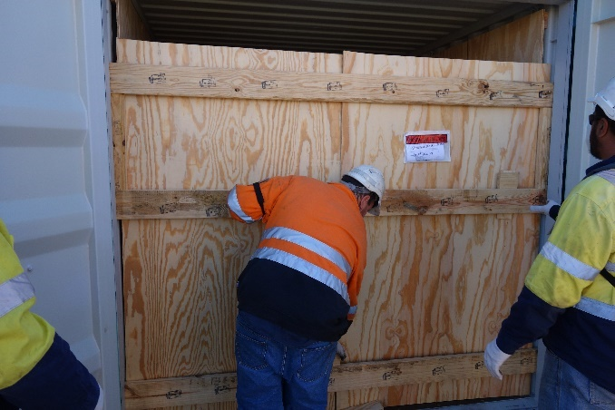

#### 9.1.7.4 Fumigation

Fumigation may be required for shipments being imported by sea. Fumigation is carried out by a licensed and regulator-accredited fumigator prior to loading on the vessel. Transport documentation associated with the carriage of cargo transport units under fumigation must show the date of fumigation, the type and amount of fumigant used, and give instructions for the disposal of the residual fumigant, including fumigation devices if used (Refer section 9.9 of the IMDG code). Special requirements may apply for fumigation when BMSB requirements are involved. (Refer 8.3.1).

### 9.1.8 Marking and Placarding

#### 9.1.8.1 Placarding for Sea Freight

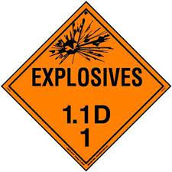Placarding and marking of cargo transport units (freight containers) must comply with chapter 5.3 of the IMDG Code. Placarding is not required on the CTU for any quantity of class I.4 S explosives. The placard of not less than 25 mm square for the appropriate division of explosives will be clearly displayed, one on each side and one on each end of the cargo transport unit. Where a single proper shipping name is transported in the cargo transport unit, the proper shipping name of the contents shall be marked on at least both sides in letters not less than 65 mm, in a contrasting colour. The UN number shall be displayed in black digits not less than 65 mm high on a white or orange background and does not obscure or detract from the other elements either within the class 1 diamond or adjacent to Class I diamond.

#### 9.1.8.2 Placarding for Road Transport in Australia

For road transport in Australia, marking freight containers is done in accordance with section 3.3 of the AEC. When containers are loaded with at least 1,000 kg of explosives or 20,000 detonators, the sides of the freight container or the vehicle must be marked with Emergency Information Panels. Where there are mixed UN numbers within the freight container, no UN number and no proper shipping name is required and the Hazchem Code is E.

## 9.2 Shipping

### 9.2.1 Dedicated Charter

The vessel will be certified and insured for carriage of explosives. It would normally be “geared” meaning cargo can be unloaded by the ship’s on-board cranes. This will usually be compulsory depending on which port the vessel is calling to unload.

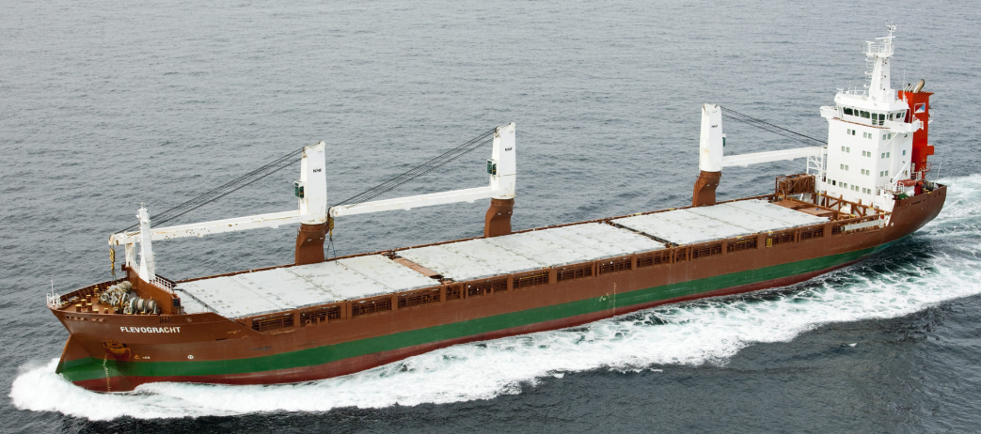

Note the cargo cranes on the ship.

In this case the importer charters (rents) either a whole vessel, or space on a vessel for a voyage from the load port to the discharge port. Bookings for these vessels are made via a ship broker. A ship broker will take the Importer’s requirements (number of containers, load, discharge port) to the market of available ship owners and negotiate an appropriate ship on the charterer’s behalf.

This vessel may carry other cargo, (explosives or non explosives) and may stop at other ports during the voyage. These vessels will usually call to a dedicated explosives port in Australia such as Port Alma due to that Port having higher explosive limits and therefore allowing more explosives to be carried.

#### 9.2.2 Liner Service

In the case of liner shipping the Importer contracts with a liner shipping company, e.g., ANL, or Swire, for the voyage from the load port to the discharge port. Liner ships operate in regular schedules between nominated ports and carry general cargo which may not be compatible with explosives. Most liner companies will not accept explosives. Some liner companies which accept explosives will not carry them on all services or on all vessels. Liner ports generally have lower NEQ limits reducing the quantity of explosives which can be imported. Finally, some intermediate ports on liner services will not allow the through carriage or transhipment of explosives. These reasons mean the preferred method of importing commercial quantities of explosives is via tramp shipping or dedicated charter.

Typical Liner vessel. Note lack of on-board cranes, and large number of containers which can cause compatibility problems for carriage of explosives.

Bookings on these ships will be made by the shipper or Importer (depending on the Incoterm) either directly with the shipping line, or more commonly, via a freight forwarder.

### 9.2.3 Vessel Suitability

Prior to importing/exporting explosives, the suitability of any shipping provider should be thoroughly checked to reduce the possibility of any unexpected or unanticipated outcomes which may lead to increased risks.

Prior to importing/exporting explosives, the suitability of any shipping provider should be thoroughly checked to reduce the possibility of any unexpected or unanticipated outcomes which may lead to increased risks.

Vessel Suitability Checklist available in Appendix J.

## 9.3 Importation Documentation Process

### 9.3.1 Import Licences

The licence to import Explosives must be for the state in which the import will take place. Once imported into that state, the Importer can transport the explosives to another state under transport licences/regulations. The Importer does not need a separate import licence for a state to which goods are being transported by road. Huracan will import explosives internationally into only either Queensland or NSW and will ensure adequate licencing prior to importation.

### 9.3.2 Australian Border Force/Customs Entry

The value, quantity and other details of the import of explosives must be declared to Australian Border Force before approval will be granted to unload. This is handled by a licensed Customs Broker. Australian Border Force keeps a list of current licensed brokers on their website.

The Importer is to obtain from the Shipper the following documents:

* Commercial Invoice showing incoterm and freight amount
* Packing List
* Fumigation Certificate (if required)
* Bill of Lading
* Dangerous goods declaration

The DGAir (Customs Broker), will perform an “import lodgement” with Australian Border Force using the above documents.

This lodgement will be compared to a similar lodgement performed by the Carrier’s Agent. If the details match and all information has been provided then the authorities will provide a release, which allows the Importer to collect the cargo from the wharf or airport.

It is usual practice for the Importer to put their Customs Agent in contact with the Carrier’s Agent to ensure they both lodge the same information with ABF to ensure delays are minimized. Delays can be caused by different reference numbers or typographical errors in one or both party’s lodgments.

When the Importer’s Customs agent receives the ABF release, it should be forwarded to the Carrier’s agent.

### 9.3.3 Department of Agriculture, Water and the Environment

The Customs Broker also lodges the appropriate documents with the Department of Agriculture to obtain permission for the Importer to collect the goods. Department of Agriculture has specific inspection requirements for import containers. When containers are to be de-stuffed from a container at a rural location, i.e. outside the metropolitan area, then they require that a “Tailgate Inspection” be performed before leaving the Port.

A Tailgate Inspection requires the container to be opened and inspected inside and out for the presence of foreign matter, particularly biological matter.

Should the discharge be at a dedicated explosives port then the Customs Broker will also make a booking directly with the Department of Agriculture inspection officer to attend at the Port and inspect the containers.

Should the discharge be at a Liner Port, the container will be taken to the nearest facility which can cater for the Tailgate Inspection.

Department of Agriculture has less interest in air freight imports as the cargo is unpacked from the airline CTU at the airport, which is always in an urban area.

#### 9.3.3.1 Brown Marmorated Stink Bug (BMSB)

BMSB is of particular concern to Australian authorities. A BMSB season is advised each year and any shipments from target countries are affected. The Department of Agriculture nominates target countries for each season. Any target high risk or target risk goods which are manufactured in, or shipped from or through the target risk countries will be subject to BMSB seasonal measures.

The Department will be monitoring a number of emerging risk countries (watch list countries) throughout the season. Target high risk and risk goods from these countries may be subject to random onshore inspections to verify freedom from BMSB contamination. Explosives have been categorised as “target high risk goods” by the Department of Agriculture and require mandatary treatment when shipped from target countries. The Department of Agriculture has approved certain fumigators around the world who are authorised to provide BMSB fumigation measures. The list can be found on the Department of Agriculture websites. Any fumigation carried out by a non-approved provider will be considered to have not been fumigated and a re-treatment will have to be done at time of discharge.

### 9.3.4 Notificaton of Import to State Regulator

A notification of Importation the explosives must be submitted prior to importing explosives via Air or Sea with the applicable state authority.

* For Queensland, this form must be submitted to the Chief Inspector of Explosives at least 7 days prior to the activity being undertaken.
* For NSW, this form is to be submitted to SafeWork NSW at least 5 working days prior to the activity being undertaken.

Advise the applicable state inspectorate of any changes to the notified arrival times and discharge dates as soon as practicable and any other issues that impact upon the import.

### 9.3.5 Port Authority Notification

The Importer must advise the port authorities in writing as to who will be the Authorised Representative.

## 9.4 Import Handling Operations

### 9.4.1 Air Freight

Huracan preferred method of importation will be air freight. For airfreight imports the explosives will arrive at the airport and will be unpacked from the airline CTU by the airline. The carrier’s agent will collect the goods from the airline and stage them at a Bonded Warehouse to await import clearance by ABF. The Importer should put their Customs Broker in contact with the Carrier’s Agent.

Huracan’s Customs Agent will lodge the documents when ABF clearance is granted there will be a certain number of days to arrange collection from the carrier’s agent. Collection must be by an approved explosive transport company. After the expiration of the “free days”, there will be a charge for storage.

### 9.4.2 Sea Freight

#### 9.4.2.1 Liner Port

Liner Port operations are designed to remove the explosives from the port precinct as soon as possible to avoid interaction with non-compatible general cargo which may also be at the Port.

The Importer’s Customs Agent will perform the ABF clearance which they will send to the Shipping Line who will liaise with the port stevedore. The Stevedore will generally plan to remove the explosive container/s from the vessel before any other container. The Importer must have the approved explosive transport company standing by at the time of discharge to collect the container “under hook”. Under Hook means that instead of unloading the container and it being left on the wharf for later collection, the transport operator will be called into the wharf by the stevedore and the container will be loaded directly onto the truck. The import container will usually be directed immediately to a nearby inspection location for the Department of Agriculture Tailgate Inspection before being approved for travel to its final destination.

#### 9.4.2.2 Charter Port

Charter sea freight vessels will generally call to non-liner ports. These ports will generally have higher NEQ levels allowing the importation of greater quantities of explosives.

The Importer will need to be more closely involved with operations at these ports. They must liaise with the port authorities, arrange the stevedores and road transport, and have an authorised representative at the Port.

Explosives are not usually discharged between sunset and sunrise or during electrical storms for safety reasons. This can lead to issues where other vessels, which can work cargo, are waiting to discharge. The Port Authority will clarify the situation.

#### 9.4.2.3 Stevedores

Huracan in consultation with the Customers Broker must make arrangements in advance for a port Stevedore to provide labour to discharge the containers. Stevedore shifts are generally booked for 8 hours at a time, and advance notice is required when booking labour for a weekend discharge.

#### 9.4.2.4 Transport

Huracan in consultation with the Customers Broker (DGAir) must ensure that sufficient transport is standing by to ensure no delays are incurred due to lack of trucks. Transport paperwork must be provided by the Importer to the transport operator in advance to enable them to plan the number of trucks, routing, etc.

### 9.4.3 Air Freight and Sea Freight - Authorised Representative

The licensed Importer (Huracan) has nominated DGAir to be their nominated Authorised Representative at the Port during the time of discharge. This representative will be formally identified prior to the Importation and must be: -

* An appropriate person who is authorised to possess explosives
* Competent in the handling of the explosive
* Are aware of their obligations and relevant requirements under the Act
* Trained in the hazards and properties of explosives
* Are able to recognise a dangerous situation
* Work within Huracan’s ESSP and our associated procedures.

The Authorised Representative of the licensed Importer is responsible for the inspection of the container and/or the imported products at the Port before being offered for transport and is responsible for authorizing remedial action should this be required.

Huracan will ensure Huracan’s representative agent is available during the entire loading and unloading of the explosives.

The representative of the licensed Importer will be competent in the matters that can reasonably be expected to occur, such as explosives safety and security, biosecurity, transport and other matters. The representative will have knowledge of the explosives being imported and their properties and be able to determine if a load is safe for transport.

### 9.4.4 Resolution of Issues

Issues which may be identified at the time of import could include: -

* Inadequate, damaged or potential to damage packaging
* Incorrectly marked boxes
* Inadequate securing of the cargo
* Shifted cargo
* Foreign matter inside or outside the container

Issues related to Explosive Issue Resolution must be actioned as soon as reasonably practicable through consultation between DGAir and the Huracan Operations Manager, deamed the Responsible person for all Explosive matters. The following are potential issues and issue resolution guidelines.

#### 9.4.4.1 Inadequate Packaging

If the packaging is found to be inadequate, such as wet, damaged or collapsed packaging, nails or dunnage with the potential to penetrate the packaging during transport then steps must be made to first make the area safe. An attempt to rectify the packaging should be made in consultation with the Huracan Authorised person and the DGAir nominated, competent person. Any issue that can not be rectified must be referred to the applicable state explosive directorate, and a plan must be made for safe transportation to the nearest Government Explosive Reserve for unpacking, remediation and rectification. All issues related to non-compliance must be recorded within the Huracan Information Management System (HIMS). When applicable, action items will notify the explosive manufacturer and their packing agent.

#### 9.4.4.2 Incorrectly Marked Boxes

In the event that an explosive box has been incorrectly marked, then an attempt to rectify the issue should be made in consultation with the Huracan Authorised person and the DGAir nominated competent person. In the event that the resolution is inadequate, then the issue should be referred to the applicable state explosive directorate, and a plan must be made for safe transportation to the nearest Government Explosive Reserve for unpacking, remediation and rectification. All issues related to non-compliance must be recorded within the Huracan Information Management System (HIMS). When applicable, an action item will notify the explosive manufacturer.

#### 9.4.4.3 Inadequate Securing of the Cargo

If the cargo is found to be inadequately secured then steps must be made to first make the area safe. An attempt to rectify the issue should be made in consultation with the Huracan Authorised person and the DGAir nominated, competent person. Any issue that can not be rectified must be referred to the applicable state explosive directorate, and a plan must be made for safe transportation to the nearest Government Explosive Reserve for unpacking, remediation and rectification. All issues related to non-compliance must be recorded within the Huracan Information Management System (HIMS). When applicable, action items will notify the explosive manufacturer and their packing agent.

#### 9.4.4.4 Shifted Cargo

If the cargo has shifted during transport then steps must be made to first make the area safe. In consultation with the Huracan Authorised person and the DGAir nominated, competent person, an attempt to make the cargo safe may include re-packaging, but only if safe. If the issue can not be rectified must be referred to the applicable state explosive directorate, and a plan must be made for safe transportation to the nearest Government Explosive Reserve for unpacking, remediation and rectification. All issues related to non-compliance must be recorded within the Huracan Information Management System (HIMS). When applicable, action items will notify the explosive manufacturer and their packing agent.

#### 9.4.4.5 Foreign Matter Inside or Outside the Container

If foreign matter is found inside a container, then in consultation with the Huracan Authorised person and the DGAir nominated competent person, depending on the foreign matter, an action plan should be made to remediate the issue, which may include the Department of Agriculture for Fauna and Floura foreign matter or the Australian Border force. All issues related to non-compliance must be recorded within the Huracan Information Management System (HIMS). When applicable, action items will notify the explosive manufacturer, their packing agent and the explosives directorate.

#### 9.4.4.6 Out of Date Explosives, Leaking Material, Out of Specification

An unlikely issue as the explosives are direct from the manufacturer, but if it does occur, then the DGAir competent person should consult with the Huracan Authorised person. First, the area should be made safe and must be referred to the applicable state explosive directorate, and a plan must be made for safe transportation to the nearest Government Explosive Reserve for unpacking, remediation and rectification. All issues related to non-compliance must be recorded within the Huracan Information Management System (HIMS). When applicable, an action item will notify the explosive manufacturer.

### 9.4.5 Fumigation

When an import of explosives requires fumigation or quarantine, the importer will notify the Explosives Inspectorate immediately and provide the intended fumigation facility and written advice about the process they are using to handle and store the explosives prior to consigning from point of import.

The Department of Agriculture Inspector may order a fumigation to be carried out on a container if: -

* Mandatory fumigation was not conducted at the load port;
* Fumigation was conducted at the load port by a provider who is not approved; or
* Foreign matter/biosecurity actionable material is found inside or outside the container.

If the Port of import is configured for fumigation, then arrangements must be made to conduct the fumigation before the container leaves the Port.

Arrangements must be made immediately with the port authority. The Importer must supply:

* Risk Assessment
* Lay out plan
* Timeline
* Details of approved fumigator
* Earthing equipment / lightning protection

to obtain any necessary approval from the port authority.

Each Port will have its own rules around fumigation. Other vessels may or may not be allowed to operate cargo while fumigation is being performed at the Port.

If the Port is not configured for fumigation, then the container may need to travel to the nearest approved facility to have the fumigation performed.

### 9.4.6 Pre-Arrival Checklist

To minimise delays and unexpected outcomes, the Importer should carry out a pre-arrival check of the systems and procedures for any planned explosive arrival.

DGAir has a suitable checklist as provided in Appendix 2 of the AEISG Code of Practice – Import of Explosives’; however this should be supplemented with more specific detail relevant to any particular shipment.

## 9.5 Preparation for Road Transport

Transport of explosives in Australia is regulated by individual States and Territories. Huracan will contract Energy Freighter, out of Roma for the transportation of explosives when possible, or another suitably qualified DG freight company will be nominated and will have its own safety and security management plans consistent with the Huracan’s

The contractor and the driver have obligations under the transport company’s safety and security management plans to ensure: -

* Explosives are safe for transport;
* Cargo is appropriately secured;
* Description, product name, codes are correct and in accordance with transport documentation;
* Placards are in place and appropriate to the cargo being carried; and
* They know the properties of the explosives being transported and the actions to be taken in case of an emergency situation.

The transport route to be followed should be in accordance with the documented route and risk assessment. Documentation should be in order when accepting the explosives for transport and delivering them for the next part of their life cycle.

The Importer who consigns explosives for road transport shall prepare transport documentation, otherwise known as a cart note, for each container being unloaded. This document will be formatted as per requirements in the AEC (Chapter 4).

Three copies of the cart note are prepared. The authorised representative will sign, the transport company representative/driver will sign and the consignee who receives the cargo will sign. Each party retains one copy.

The Importer or consignor will be expected to audit the transport company at regular intervals to ensure it is meeting its obligations.

## 9.6 Container Unloading

### 9.6.1 Deconsolidating the Container

The freight container, having been transported from the Port to the destination for the first journey, will be set down. This must be in the area where it is to be unloaded or to be unloaded at a later date.

Procedures for unloading the container are as follows: -

* Verify the seals on the container match those recorded on the transport documentation;
* Ensure there has been no tampering of the container;
* The seal and the seal identity number will be recorded under the security plan; and
* Upon opening the doors, the container is normally vented for two hours before entering or beginning to unload the container.

Upon discovering any issues that require rectification, the unpackers will contact the Importer for advice on addressing those issues.

Those issues could include:

* Quality of the product;
* Non-compliant package markings;
* Unauthorised product; and/or
* Damage to packaging or product.

The shipment or parts of the shipment will be treated in accordance with the unpacker’s quality plan for quarantining while awaiting rectification of the issues. This product will then need to be identified as under quarantine, leading to rectification to declare the product is of acceptable quality or to reject the product. Depending upon the product, pallets may need to be stacked, explosives may need to be re-packaged due to damage. A random inspection should be taken of the contents within a package to verify that the quality of the package contents are as intended. This inspection will be carried out under the quality plan to validate the integrity of the shipment received.

It is crucial that a cross check of quantity received matches the quantity shipped. Should a discrepancy be discovered the Importer will conduct an investigation to determine the source of the discrepancy and determine whether there is the possibility of stolen or lost explosives. Should the Importer suspect stolen or lost explosives, the local regulator should be advised immediately.

## 9.7 Regulatory Requirements Specific to Explosives

This section identifies the major pieces of legislation that apply to the life-cycle for the import and export of explosives and other general regulatory requirements under legislation. The Commonwealth, States and Territories have specialist legislation regulating the safety and security of explosives through the entire life-cycle. This includes import, export, supply and sale, manufacture, transport, storage and the authorisation of explosives as appropriate. In Australia, explosives safety and security legislation is predominantly legislated and administered at a State/Territory level. For import and export purposes, sea transport is regulated through the Commonwealth by the Australian Maritime Safety Authority and for air transport by the Civil Aviation Safety Authority.

There are other regulatory agencies that also have a role with the import and export of explosives including general health and safety matters, general transport, ports, harbours and marine, biosecurity, environment, customs and other business aspects.

Therefore, importers and exporters of explosives will need to consider other agencies where relevant, including:

* Department of Defence;
* Australian Border Force (Customs);
* Department of Agriculture and Water Resources;
* Australian Maritime Safety Authority (AMSA);
* Federal Attorney General;
* Department of Health (NICNAS); and /or
* Civil Aviation Safety Authority (CASA).

Agencies who are located overseas will also have a role covering the import and export of explosives, however these are not dealt with in this code. Other agencies that have a more general role, such as health and safety, are also not dealt with in this code.

Each Regulator will operate under their respective legislations which have requirements placed upon the responsible people operating in the import and export of explosives to ensure compliance with their respective legislations. These legislations will provide for administrative arrangements such as powers of authorised officers (inspectors), appointment of authorised officers, licences and permits, notifications, statutory directives, authorisation of explosives, etc.

### 9.7.1 Explosive Limits – Ports and Airports

Each Port has an explosives limit defined by the port authority, normally with the assistance of the explosives regulator. Some ports have different limits at different berths at the Port.

Liner ships call to berths being operated by their particular contracted stevedore and will only call to berths with higher explosives limits by special arrangements.

Charter ship owners will check the limits of the Port prior to accepting the booking however the obligation is on the Importer to check the details of the Port prior to making such arrangements.

Airlines know the limits applying at airports and aircraft and will not accept bookings which exceed the limits.

### 9.7.2 Chain of Responsibility

Under the Chain Of Responsibility (COR), if a person consigns, packs, loads or receives goods as part of their business, they could be held legally liable for breaches of the Heavy Vehicle National Law (HVNL) even though the person has no direct role in driving or operating a heavy vehicle. In addition, corporate entities, directors, partners and managers are accountable for the actions of people under their control. This is the ‘chain of responsibility’.

The aim of COR is to make sure everyone in the supply chain shares equal responsibility for ensuring breaches of the HVNL do not occur. Under COR laws if a person exercises (or has the capability of exercising) control or influence over any transport task, the person is part of the supply chain and therefore has a responsibility to ensure compliance with HVNL.

The law recognises that multiple parties may be responsible for offences committed by the drivers and operators of heavy vehicles. A person may be a party in the supply chain in more than one way. For example, they may have duties as the employer, the operator and the consigner of goods.

Legal liability applies to all parties for their actions or inactions. The Importer must ensure it does not put unreasonable demands on the transport company to deliver within an unrealistic time frame.

The Importer should include checks of time sheets when performing regular audits of the transport companies to ensure they have systems in place to ensure all legislation, e.g., fatigue, is being followed.

# 10 Reference Library

Legislation, regulatory and other references are consulted to ensure the Company is complying with all due obligations and our commitment for continual improvement.

Explosives Act 1999

Radiation Regulation 2017

AEISG – Code of Practice – Import of Explosives – Current Edition

AS 2187.1 – 1998 Explosives – Storage, transport and use, Part 1: Storage

AS 2187.2 – 2006 Explosives – Storage and use, Part 2: Use of explosives

Australian Code of Transport of Dangerous Goods by Road & Rail Edition 7.4

Australian Code for the Transport of Explosives by Road and Rail 3rd Edition

Amendments from Land, Explosives & Other Legislation Amendment Bill 2017

# Appendix A – Authorised Unsupervised Access Personnel

Current licences and document to be stored on Huracan’s Information Management System under the Document Report tab. Expiry date to be recorded with automated email expiry reminders.

|  |  |  |  |  |  |
| --- | --- | --- | --- | --- | --- |
| Name | Licence # | Type | Purpose | Expiry Date | Authority |
| Jon Paul Hollingworth | 2300296 | Blasting Explosives, Propellant Powders | Down Hole Perforating | 14-Sep-28 | QLD |

# Appendix B – Corporate Explosive Licence

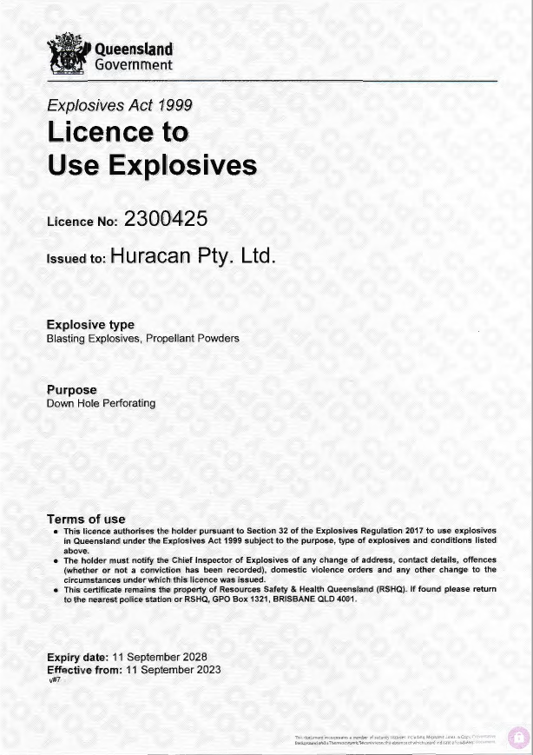

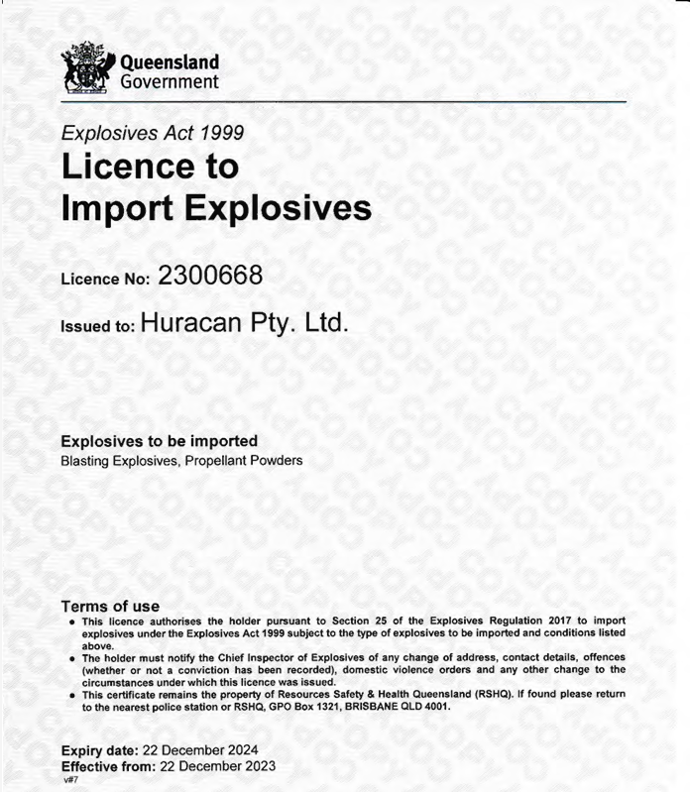

# Appendix C – Approved Vehicles for Transport of Explosives

A list of the current Approved vehicles for the Transport of Explosives list is kept on HIMS under the Document Report tab. The document format is as below. Each individual Vehicle Licence and expiry is to be recorded in the same section.

|  |  |  |
| --- | --- | --- |
| Vehicle Registration | Explosive Licence | Expiry Date |
|  |  |  |
|  |  |  |
|  |  |  |
|  |  |  |
|  |  |  |
|  |  |  |

# Appendix D – Explosive Emergency Procedure

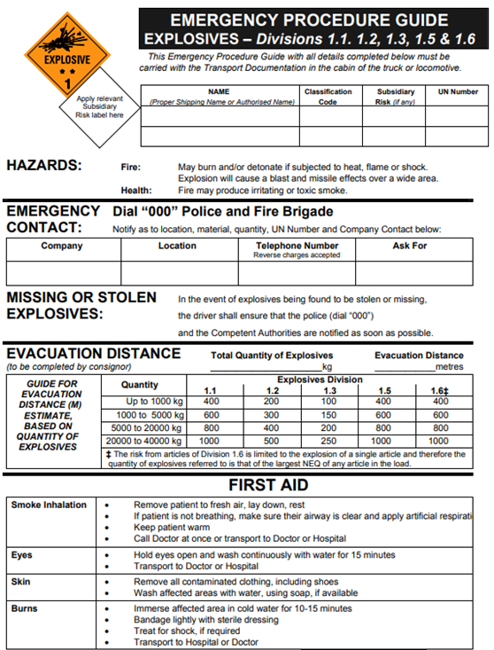

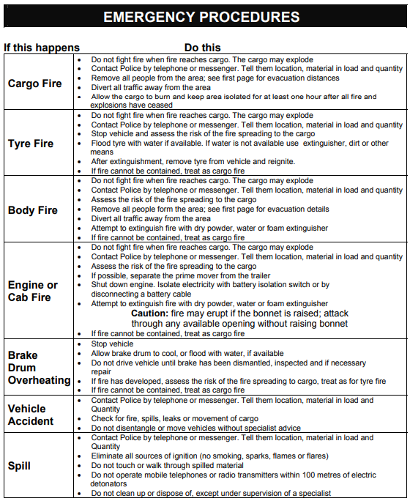

# Appendix E – Explosive Manifest

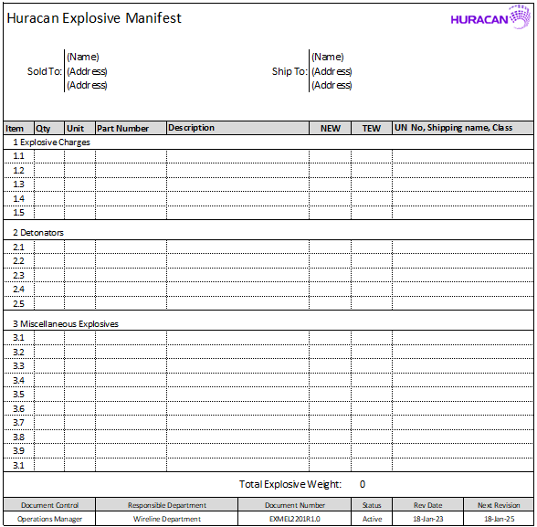

# Appendix F – Transport Risk Categories for Explosives

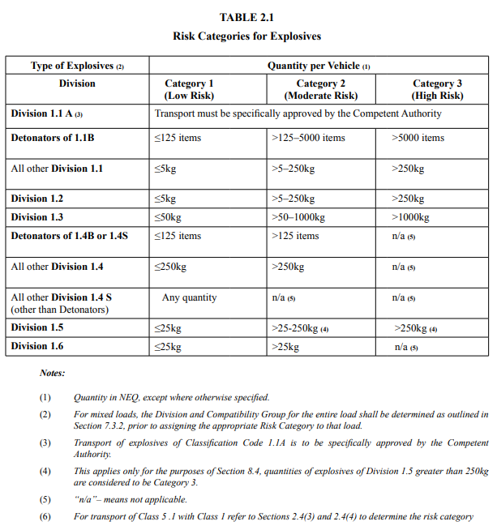

# Appendix G – Marking of Road Vehicles

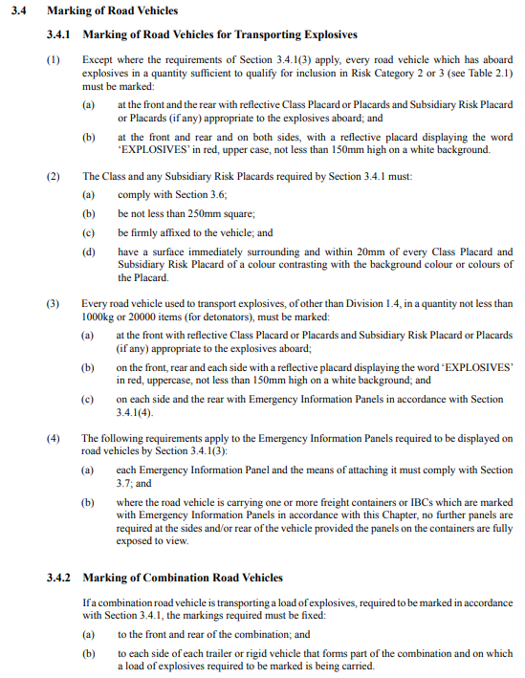

# Appendix H - Information bulletin no.71 List of authorised explosives

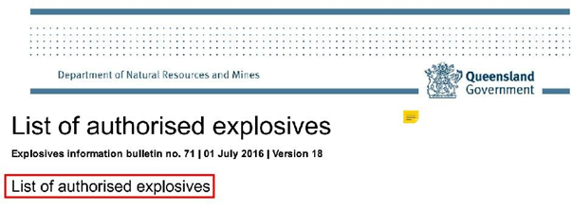

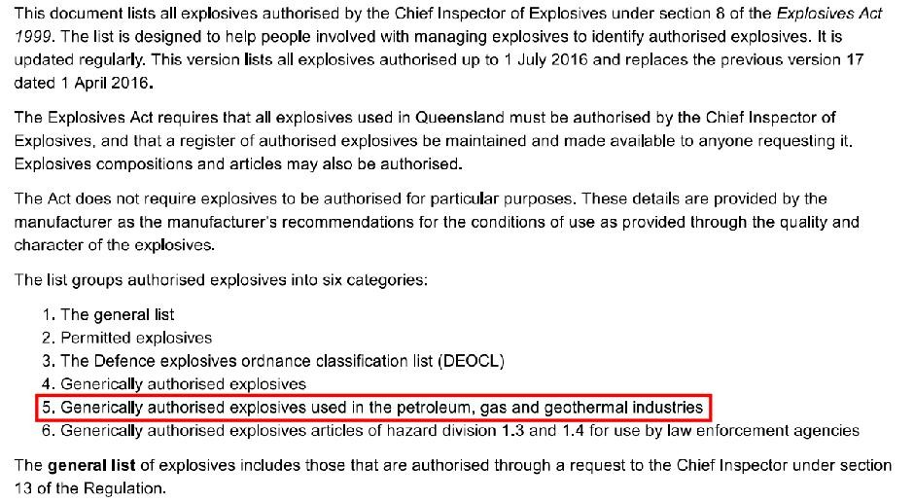

# Appendix I – Authority Contacts

|  |  |  |
| --- | --- | --- |
| Queensland | Explosives Inspectorate - Resources Safety and Health Queensland | Ph: 1300 739 868 |
| Level 19 275 George Street Brisbane City, Queensland 4000 |  |
| Australian Capital Territory | Chief Inspector of Dangerous Goods | Ph: 13 22 81 |
| A.C.T Workcover |  |
| Canberra Nara Centre |  |
| 3 Constitution Avenue |  |
| New South Wales | WorkCover NSW  92-100 Donnison Street, Gosford NSW 2250 | Ph: (02) 4321 5000  Ph: 13 10 50 |
| Northern Territory | Chief Inspector of Dangerous Goods | Ph: 1800 019 115 |
| NT WorkSafe |  |
| GPO Box 1722, |  |
| Darwin, NT 0801 |  |
| South Australia | Manager, Dangerous Substances Deptment  GPO Box 465 | PH: 1800 777 209 |
| Adelaide, SA 5001 |  |
| Tasmania | WorkSafe Tasmania  30 Gordons Hill Road | Ph: 1300 366 322 |
| Rosny Park, TAS 7018 |  |
| Victoria | Licensing Branch | Ph: 1300 852 562 |
| PO Box 279 | Fax 1800 060 727 |
| Geelong Vic 3220 |  |
| Western Australia | Dangerous Goods Officer | Ph: (08) 6251 2300 |
| Department of Mines, Industry Regulation and Safety |  |
| Locked Bag 100 |  |
| East Perth WA 6892 |  |

# Appendix J - Import Explosives Vessel Chartering Checklist

|  |  |  |  |
| --- | --- | --- | --- |
| **Criteria** | **Information** | **Statement on compliance** | **C/NC/NA** |
| **1. Vessel Specifications** | Compare vessel length, draft, air draft, crane reach with load and discharge port limits |  |  |
| **2. Crew List** | Must comply with current AMSA regulations, marine notices, international sanctions |  |  |
| **3. Sanctions Check** | Check whether vessel, owners and operators or managers are on any international sanctions list and have no past history with countries on sanction lists |  |  |
| **4. Independent Vessel Vetting Service** | Optional 3rd party independent vetting of vessel to guarantee suitability to carry Class 1 |  |  |
| **5. Ship survey Report** | Can be used with or in addition to independent vetting in point 4 |  |  |
| **6. Vessel Certificates** | Obtain Dangerous goods documents, DOC, SMC, Class certificates, ISSC, P&I certificates to ensure certificates and insurance are current |  |  |
| **7. Ship crane inspection reports** | Obtain reports, test certificates and maintenance logs for ropes, hooks, sheave blocks and shackles. Stevedores will check these documents for currency prior to operating cargo |  |  |
| **8. Crane Markings** | Ensure crane markings are clear and visible. Stevedores will not operate cranes unless markings are clearly visible |  |  |
| **9. Check last 6 cargoes carried by vessel** | Carriage of Department of Agriculture actionable cargoes such as wheat and grains within the last 6 cargoes presents a risk of residue being on board and failure during inspection |  |  |
| **10. Firefighting Equipment test certificates** | Firefighting certificates and inspection regime must be current |  |  |
| **11. History of Class 1 carriage** | Considering the strict rules and stringent inspection protocols in Australia it is always preferable to use a carrier with Class 1 experience |  |  |
| **12. Bow Thruster** | Vessels with bow thrusters are usually exempt from one or more tugs for berthing and sailing |  |  |

# Appendix K – Explosives Importation Guidelines

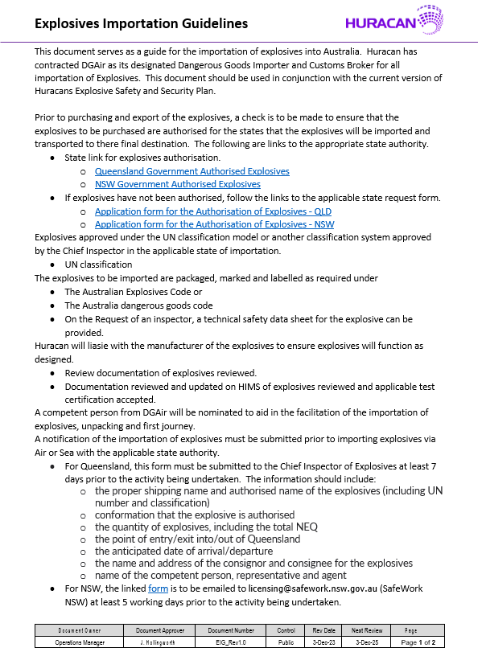

# Appendix L – List of Potential Explosives to be Imported



